**Experiment No : 8**

**AIM**

Familiarization of LINUX Commands.

**CO2**

Perform system administration task.

**Procedure**

1. ip addr

used to uniquely identify the device in the network.

Output

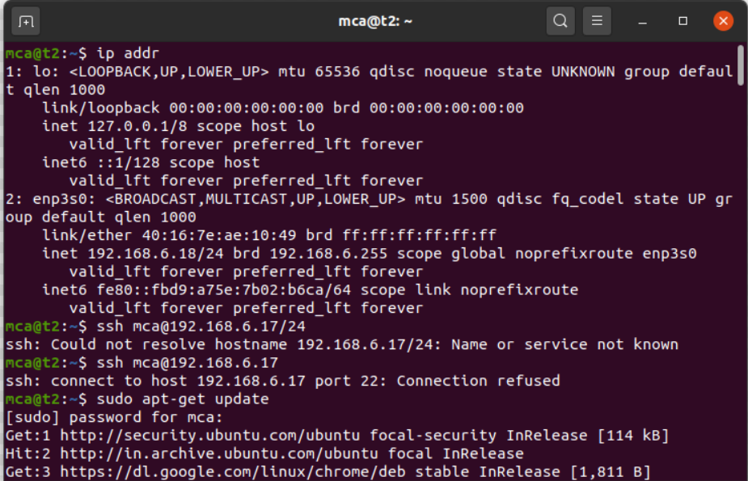

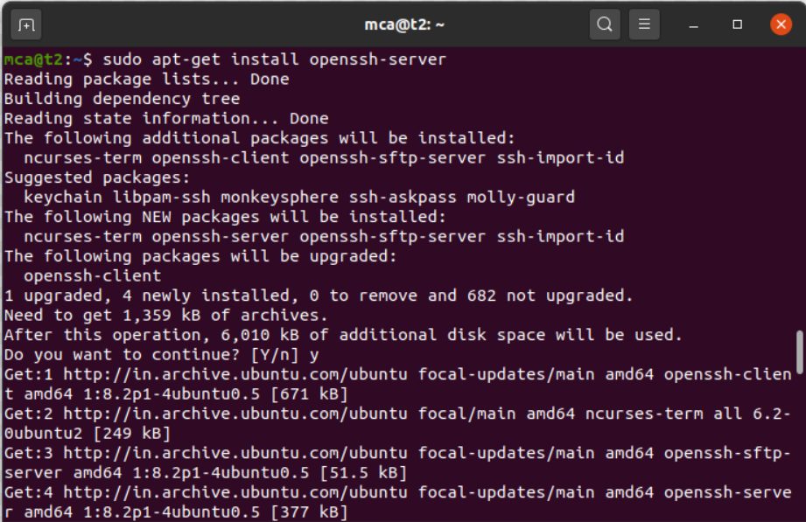

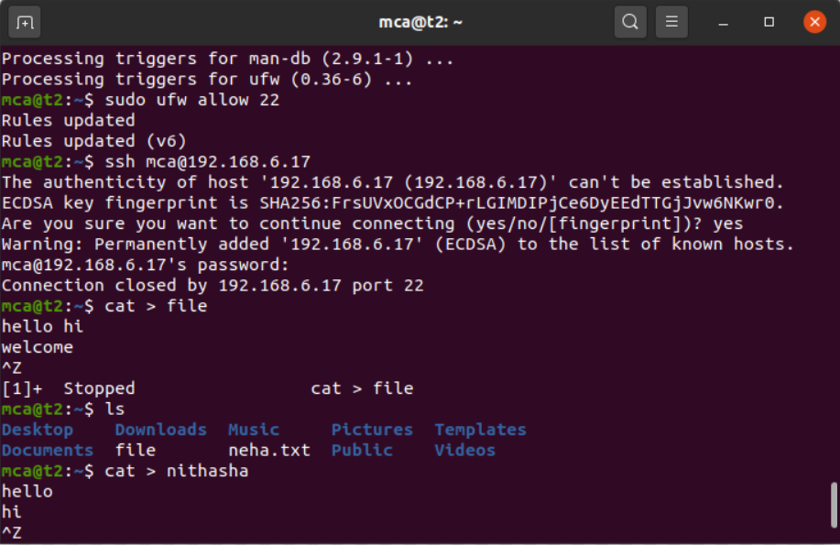

1. ssh –keygen

ssh stands for secure shell protocol used to securely connect to a remote server of a system. ssh is secure in sense it transfers data in encrypted form between host and client. This command generates key for secure connection.

Output

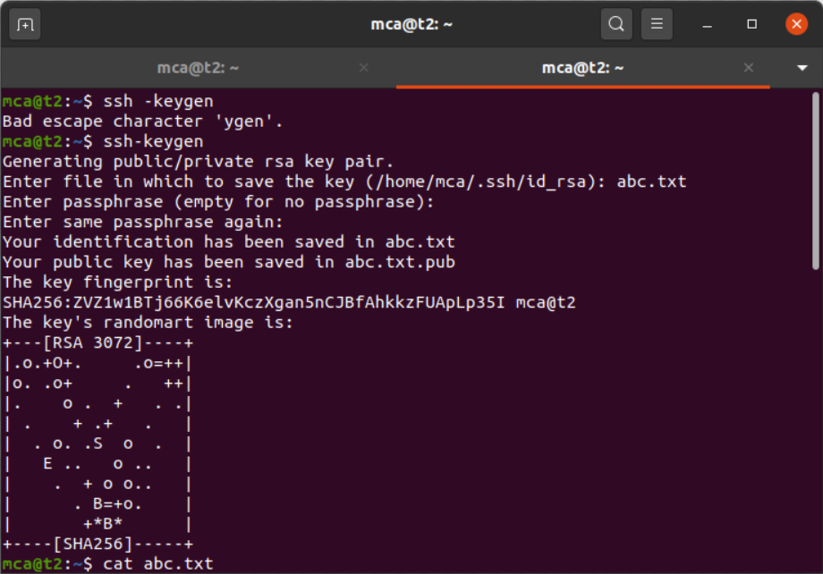

1. ps

currently running process of the user.

Output

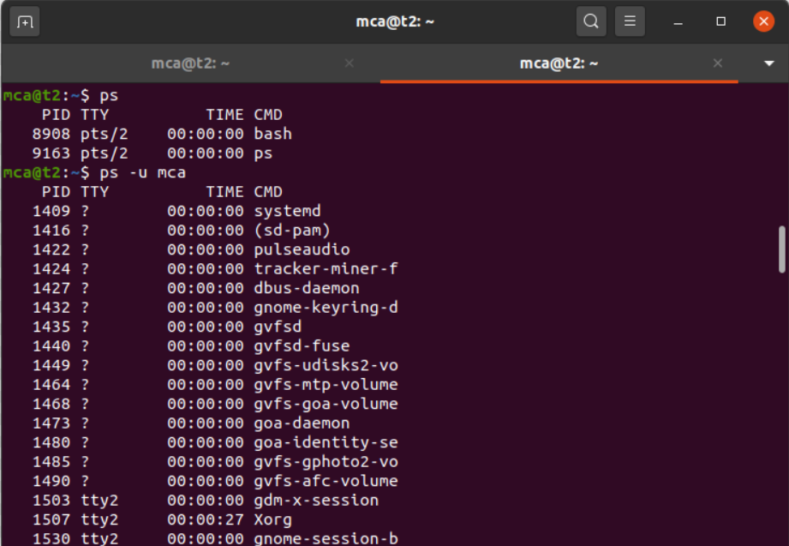

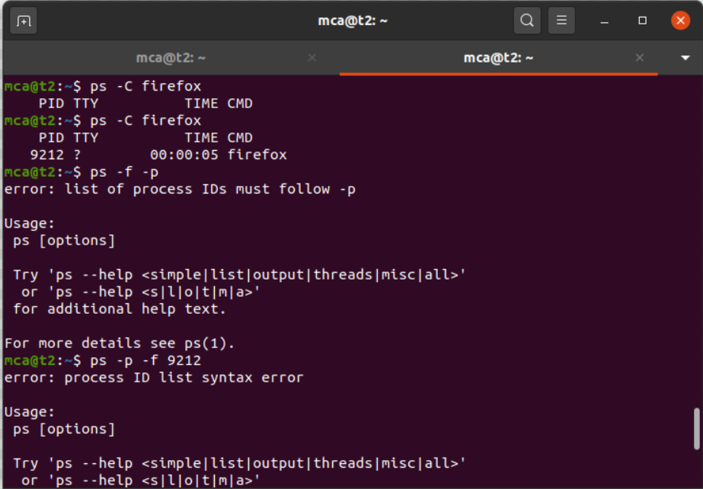

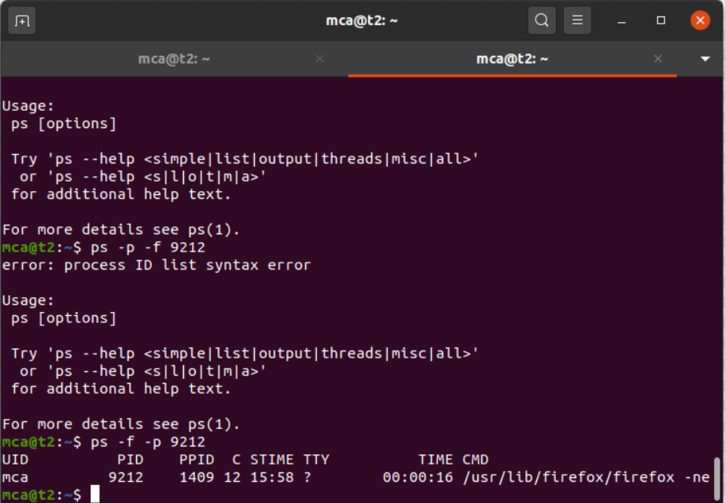

Result

The program has been executed and output has been verified.